KEY - CRQ Set 1 Directions (1–3): Analyze the documents and answer the short-answer questions that follow each document in the space provided. Base your answer to Document 1 below and on your knowledge of social studies.

Document #1
An excerpt from The Ascent of Man, Before the Neolithic Revolution
… Man survived the fierce test of the Ice Ages because he had the flexibility of mind to recognize interventions and to turn them into community property. Evidently the Ice Ages worked a profound change in the way man could live. They forced him to depend less on plants and more on animals. The rigorous of hunting on the edge of the ice also changed the strategy of hunting. It became less attractive to stalk single animals, however large. The better alternative was to follow herds and not to lose them – to learn to anticipate and in the end to adopt their habits, including their wandering migrations. This is a peculiar adaptation – the trans-humance [nomadic] mode of life on the move. It has some of the earlier qualities of hunting, because it is a pursuit; the place and the pace are set by the food animal. And it has some of the later qualities of herding, because the animal is tended, and as it were, stored as a mobile reservoir of food…
- Jacob Bronowski, The Ascent of Man, Little, Brown and Company
1. Explain the historical circumstances that led to the developments occurring during this time period as described in this excerpt. [2]
- The Ice Ages (climate and environment) made people depend more on animals and less on plants
- Due to the climate (cold temperatures), it was better to follow herds of animals and not to lose them since farming was not an option.
- The Ice Ages encouraged a nomadic lifestyle
- A nomadic lifestyle was a result of hunting animals
- The migration of animals resulted in a nomadic lifestyle

Document #2

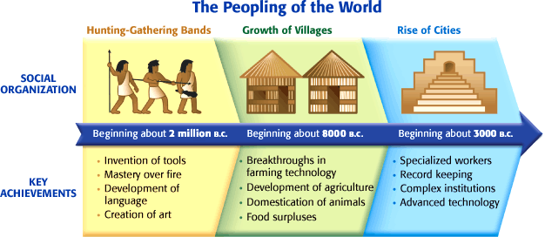

Historical Context: refers to the historical circumstances that led to this event/idea/historical development.

2. Based on this timeline, explain the historical circumstances that led to the Neolithic Revolution. [4]

- Invention of tools
- Mastery over fire
- Development of language
- Creation of art
- Breakthroughs in farming technology
- Development of agriculture
- Domestication of animals
- Food surpluses

3. Identify AND explain a cause-and-effect relationship between the events and/or ideas found in these documents.

Be sure to use evidence from both Document 1 and 2 in your response. [4]

- Because people followed a nomadic lifestyle and hunted animals, they learned how to create tools. Creating tools led to other innovations and led to breakthroughs in farming, which then encouraged people to stay in one place since they were able to plant their own food. People domesticated animals and began to keep records and became skilled in specialized areas since they had more time now that they weren’t spending time hunting animals. Civilizations began.

